**AWS Assignment**

**Create EC2 Instance:**

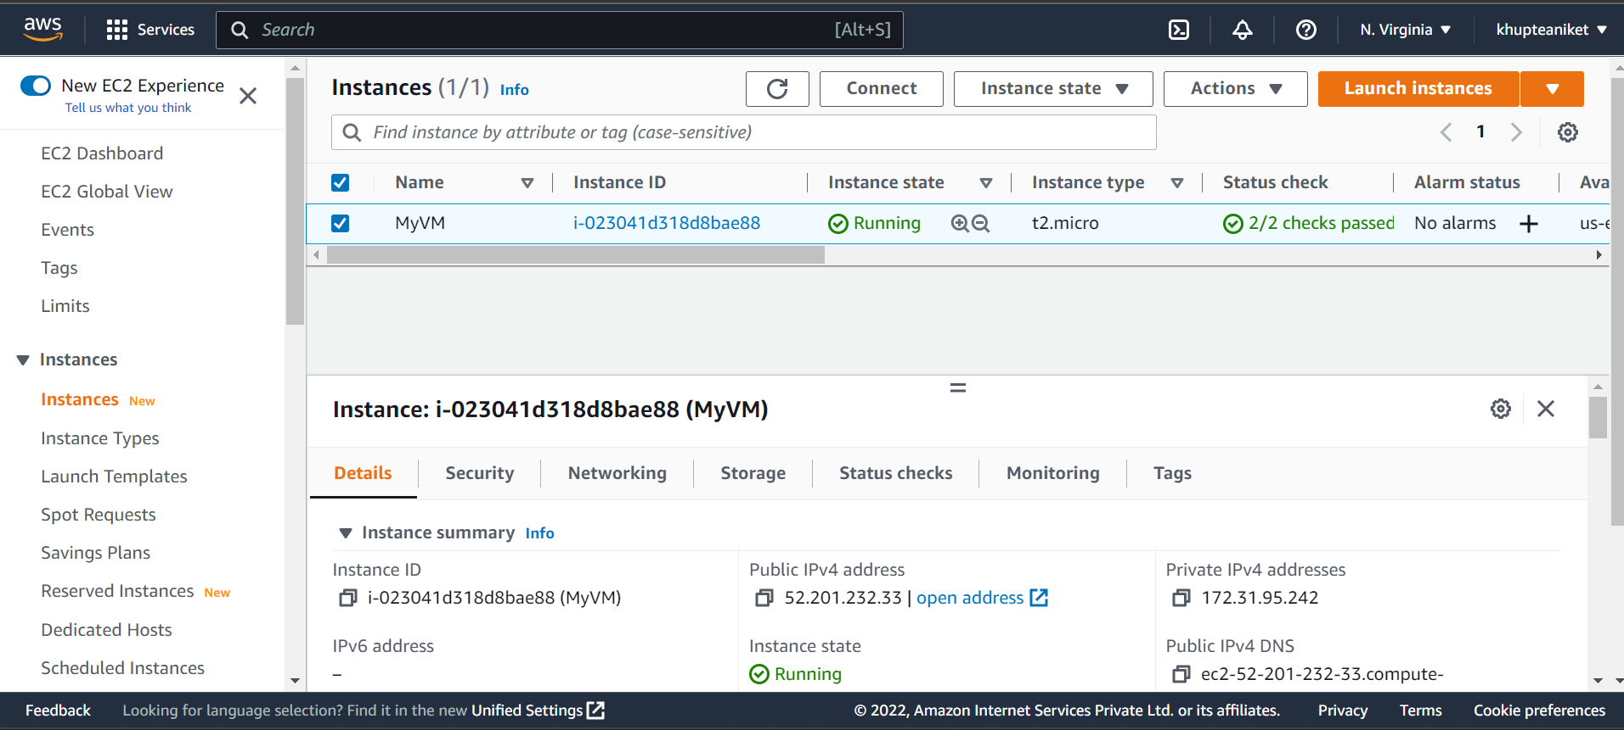

**Create RDS Instance:**

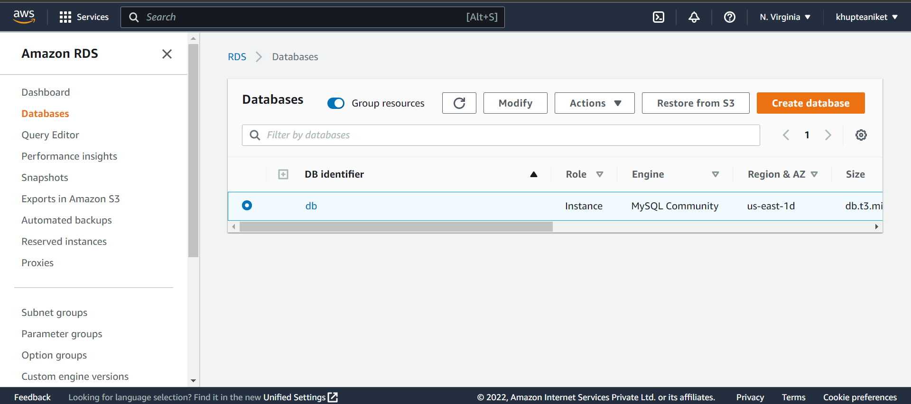

**Connect to MobeXTerm:**

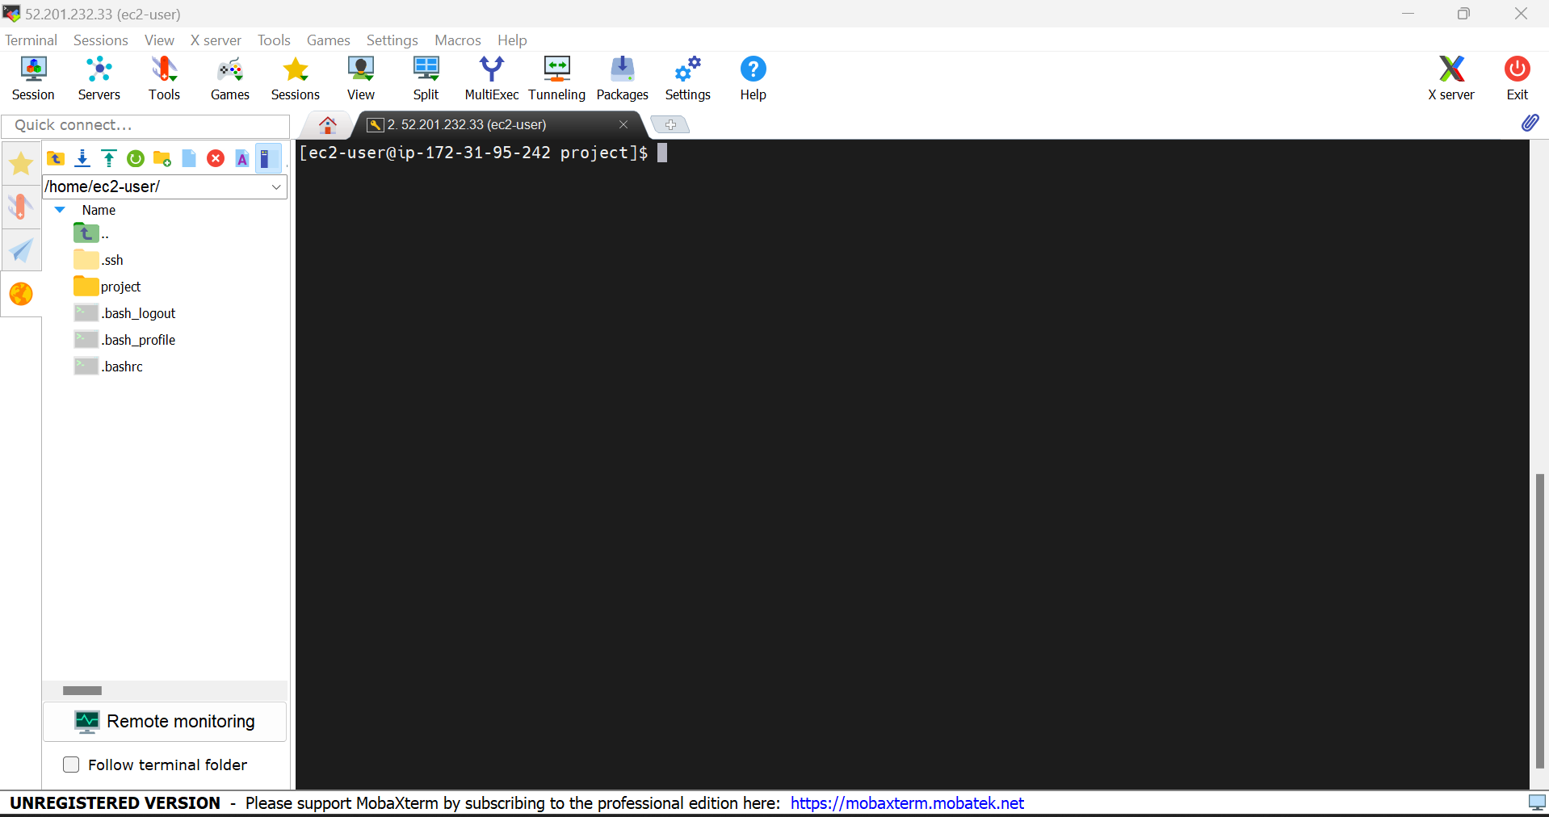

**Connecting RDS with Workbench:**

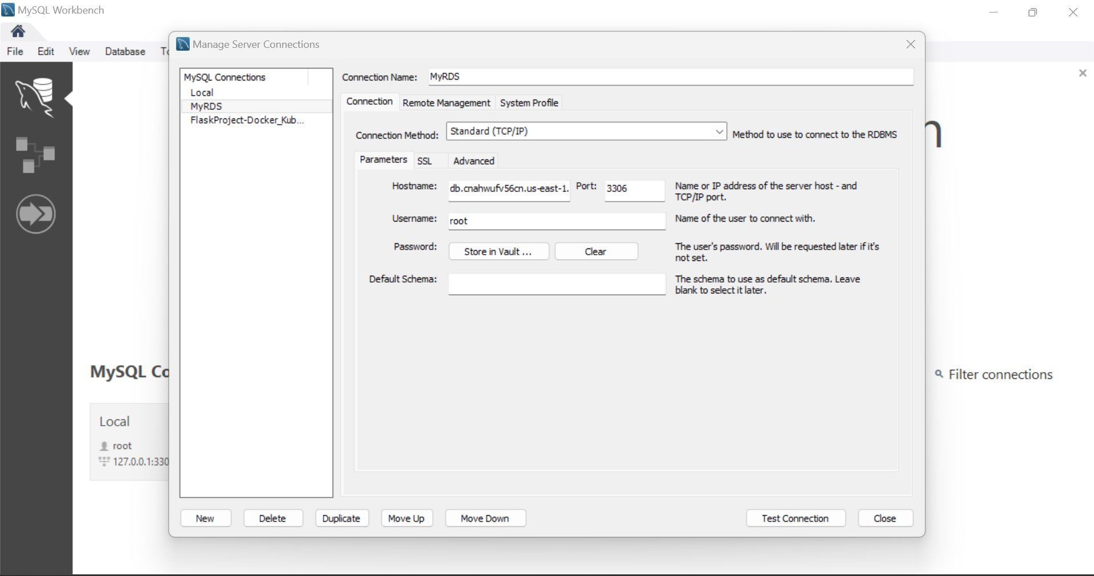

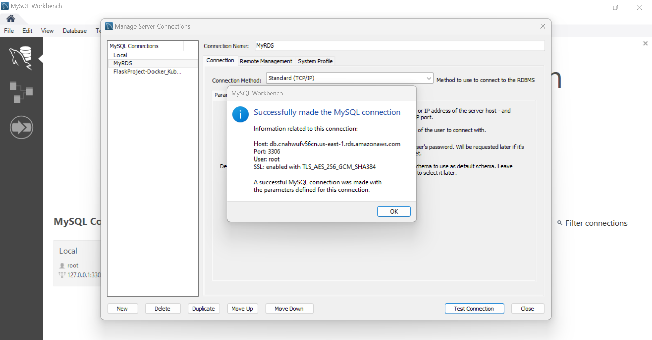

**Upload Project Files On AWS S3:**

